

目录

[**一、概述** 1](#_Toc515466917)

[1. 什么是教链（JLL） 3](#_Toc515466918)

[2. 教链（JLL）使命·愿景·目标 3](#_Toc515466919)

[3. 教链（JLL）的价值观 4](#_Toc515466920)

[**二、教链（JLL）市场背景** 7](#_Toc515466921)

[1. 教育市场背景 7](#_Toc515466922)

[2. 传统教育产业现存痛点 10](#_Toc515466923)

[**三、教链（JLL)创新与变革** 14](#_Toc515466924)

[1. 变革的核心 14](#_Toc515466925)

[2. 利用技术重塑市场模型 14](#_Toc515466926)

[3. 行为的定义 14](#_Toc515466927)

[4. 教育产业区块链变革结果 15](#_Toc515466928)

[**四、教链（JLL）技术体系** 17](#_Toc515466929)

[1. 技术体系 17](#_Toc515466930)

[2. 应用信任体系 19](#_Toc515466931)

[3. 技术架构 23](#_Toc515466932)

[4. 多样认证体系 25](#_Toc515466933)

[5. 数据交换体系 27](#_Toc515466934)

[6. 海量存储 29](#_Toc515466935)

[7. 海量IP数据存储 35](#_Toc515466936)

[**五、教链（JLL)解决方案** 37](#_Toc515466937)

[1. 教链（JLL）社区部落 37](#_Toc515466938)

[2. 教链（JLL）DAPP应用 39](#_Toc515466939)

[3. 教链（JLL）人才、内容交易所 41](#_Toc515466940)

[4. 教链（JLL）智能合约协议 42](#_Toc515466941)

[**六、教链（JLL）发行方案** 44](#_Toc515466942)

[**七、教链（JLL）发展路径** 46](#_Toc515466943)

[1. 大梵天（计划） 46](#_Toc515466944)

[2. 因陀罗（计划） 46](#_Toc515466945)

[3. 苏利耶（计划） 47](#_Toc515466946)

[4. 伐楼那（计划）： 47](#_Toc515466947)

[5. 迦楼罗（计划）： 48](#_Toc515466948)

[**八、教链（JLL）核心成员、顾问及投资机构** 50](#_Toc515466949)

[1. 营运团队 50](#_Toc515466950)

[2. 顾问团队 53](#_Toc515466951)

[**九、投资机构** 55](#_Toc515466952)

[**十、预计时间表** 56](#_Toc515466953)

[**十一、项目风险** 57](#_Toc515466954)

[1. 政策风险 57](#_Toc515466955)

[2. 团队风险 57](#_Toc515466956)

[3. 竞争风险 57](#_Toc515466957)

[4. 黑客风险 57](#_Toc515466958)

[**结语** 58](#_Toc515466959)

Contents

[1. **Introduction** 1](#_Toc515466917)

[1. What is JLL 1](#_Toc515466918)

[2. JLL's mission, vision and goal 1](#_Toc515466919)

[3. JLL's values 1](#_Toc515466920)

[2. **The market background of JLL** 3](#_Toc515466921)

[1. Education market background 3](#_Toc515466922)

[2. The pain spots of tradication education industry 5](#_Toc515466923)

[3. **JLL's innovation and changes** 7](#_Toc515466924)

[1. The core of change 7](#_Toc515466925)

[2. Reshape market models with technology 7](#_Toc515466926)

[3. Definition of behavior 7](#_Toc515466927)

[4. The results of education industry block chain changes 7](#_Toc515466928)

[4. **JLL’s technology system** 8](#_Toc515466929)

[1. Technology system 8](#_Toc515466930)

[2. Application trust system 8](#_Toc515466931)

[3. The Technical Architecture 10](#_Toc515466932)

[4. Multiple Certification System 12](#_Toc515466933)

[5. Data exchange system 12](#_Toc515466934)

[6. Mass storage 14](#_Toc515466935)

[7. Massive IP data storage 17](#_Toc515466936)

[5. **JLL solution** 18](#_Toc515466937)

[1. Education chain (JLL) community tribe 18](#_Toc515466938)

[2. JLL DAPP applications 18](#_Toc515466939)

[3. JLL exchange for talents and contents 19](#_Toc515466940)

[4. JLL smart contract protocol 20](#_Toc515466941)

[6. **JLL issue scheme** 21](#_Toc515466942)

[7. **Development path of JLL** 22](#_Toc515466943)

[1. Grand Brahma (Project) 22](#_Toc515466944)

[2. Indra (Project) 22](#_Toc515466945)

[3. Surya (Project) 22](#_Toc515466946)

[4. Varuna (Project) 22](#_Toc515466947)

[5. Calura (Project) 23](#_Toc515466948)

[8. **JLL’s core members, consultants and investment institutions** 24](#_Toc515466949)

[1. Operation team 24](#_Toc515466950)

[2. Consultant team 27](#_Toc515466951)

[9. **Investment institutions** 29](#_Toc515466952)

[10. **Estimated schedule** 30](#_Toc515466953)

[11. **Project risks** 31](#_Toc515466954)

[1. Policy risks 31](#_Toc515466955)

[2. Team risk 31](#_Toc515466956)

[3. Competition risk 31](#_Toc515466957)

[4. Hacker risks 31](#_Toc515466958)

[**Conclusion** 32](#_Toc515466959)

1. **概述**

**1. Introduction**

1. 什么是教链（JLL）

What is Education Chain (JLL)?

教链（JLL）是基于区块链技术的开源去中心化分布式教育产业协议。教链利用JLL智能协议，将区块链技术引入以教育行业，颠覆传统教育产业，打造全球首条教育公有链，**其未来蓝图包括诸多教育领域分布式DAPP应用，一条教育产业公有链，一个人才内容去中心化交易所。**

Education chain (JLL) is an open source decentralized distributed protocol of education industry based on block chain technology. With JLL intelligent protocol, the education chain introduces block chain technology into the education industry. It will disrupt the traditional education industry and create the world's first education public chain. **Its future blueprint include many distributed DAPP applications in education, a public chain of education industry, and a decentralized exchange of personnel contents.**

1. 教链（JLL）使命·愿景·目标

Education chain (JLL)'s mission, vision and goal

使命：成为分布式创新教育的缔造者

Mission: be the founder of distributed and innovative education

愿景：重塑教育产业，共建分布式教育生态

Vision: remodel the education industry and build a distributed education ecosystem

目标：

1. 构建一个教育产业公有链
2. 创造一个分布式教育生态
3. 建立首个人才、内容、版权的去中心化交易所
4. 促成一个“自治”的教育社区
5. 成为全球范围内可信的教育平台

Goal:

1. Construct a public chain of education industry
2. Create a distributed education ecosystem
3. Set up the first decentralized exchange of talents, contents and copyrights
4. Promote an "autonomous" education community
5. Become a trusted education platform worldwide
6. 教链（JLL）的价值观

JLL's values

在设计教链（JLL）之初，如下核心价值观被贯彻始终：

At the beginning of the education chain (JLL), the following core values have always been implemented:

1. 教育产业当以分布式的形态存在，内容生产者、学生，企业、机构、社区五方可共同参与决策，同时利用Tokens（代币）全面激发教链（JLL）参与者的积极性。

Education industry will exist in a distributed form; decisions are jointly made by all the stakeholders (e.g., content producers, students, enterprises, institutions, and community); meanwhile, Tokens will be used to comprehensively motivate the participants in the education chain (JLL).

1. 教链（JLL）利用Mozilla开源协议受全体参与者监督，透明且不可篡改的运行规则使得教育产业领域的人才、教育内容创作者所作出的所有贡献都将按照规则获得收益，实现个体价值的数字资产化。

The education chain (JLL), by using Mozilla open source license, is supervised by all the participants. With its transparent and tamper-proofing operation rules, JLL will reward the contributions made by the talents and content creators in the education industry as long as they follow the rules. In this way, individual value will be transformed into digital assets.

1. 老师、学生、机构等上传的所有通过验证的内容，都将被共识算法统一量化。例如，学生投入学习的时间与学习成果，老师与机构上传的教学内容等，都将被系统识别、记录、奖励。

All content uploaded by teachers, students, institutions and others will be uniformly quantified by the consensus algorithm. For example, the time a student devoted into study and his/her results, and the teaching content uploaded by teachers and institutions will be recognized, recorded and rewarded by the system.

1. 以教育为本，以生产者为本。因教链（JLL）具有去中心化的本质，所以在整个系统中，庞大资本的力量得到了合理的限制，个体的价值得到体现。

Education and content producers are the focus of the system. With its decentralized nature of the education chain, the power of huge capital will be reasonably limited and individual value is appreciated in the whole system.

1. 教链（JLL）为非营利基金会所运行的自组织机构，根本目的并非创造利润，而是致力于服务学生、教育工作者、机构与用人单位。教链（JLL）的参与者亦会受益于教链代币增长所带来的繁荣。

As a self-organizing institute run by a non-profit foundation, JLL’s fundamental purpose is to serve students, education workers, institutions and employers, rather than creating profits. Participants in the JLL will also benefit from the prosperity brought about by the growth of the teaching chain token.

1. **教链（JLL）市场背景**

**The market background of JLL**

1. 教育市场背景

Education market background

教链（JLL）是基于区块链技术的开源去中心化分布式教育内容产业协议，在教育、网络招聘、内容出版三个万亿级的市场，利用区块链DAPP去中心化的应用，通过JLL智能协议实现跨领域、跨行业交易结构。

The education chain (JLL) is an open source decentralized distributed protocol for the education content industry based on the block chain technology. In the three trillion-dollar markets of education, on-line employment, and content publication, the JLL intelligent protocol will facilitate cross-industry and interdisciplinary trade structure by applying the decentralized block chain DAPP.

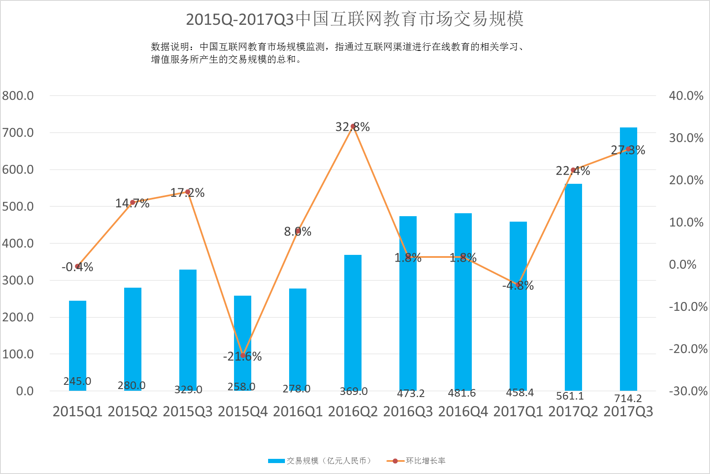

|  |  |
| --- | --- |
| 2015Q-2017Q3中国互联网教育市场交易规模 | The trade volumes of China’s on-line education market from 2015Q3 to 2017Q3 |
| 数据说明···· | Data illustration: the monitoring of China on-line education market volume refers to the sum of trades generated from all the learning and value-added services related to on-line education happening on the Internet |
| 交易规模（亿元人民币） | Trade Volume (Hundred Million RMB) |
| 环比增长率 | Increase (Quarter on Quarter) |

2016年互联网教育市场规模达到了1600亿（如上图），而随着移动互联网的普及加上新型技术的应用，用户使用习惯的延展，预计在未来3年，市场会继续保持30%的稳定增长，到2019年，市场规模达到3700亿。

The Internet education market in 2016 registered a revenue of 160 billion (see above figure). With the popularity of mobile Internet and the application of new technologies, plus the extension of users habits, this market is expected to grow by 30% each year. With this growth, the market scale will reach 370 billion in 2019.

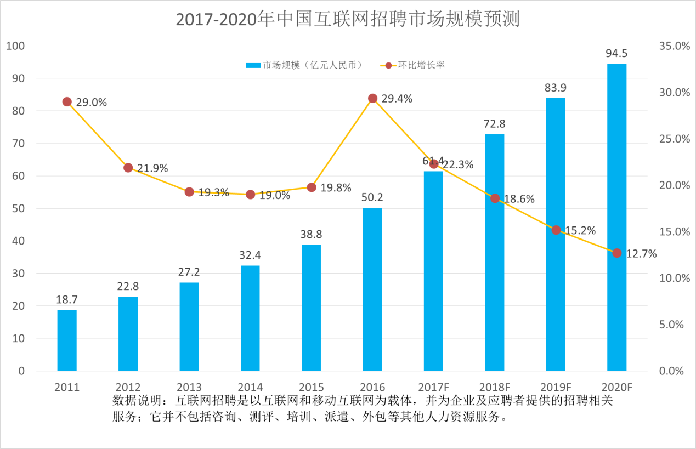

|  |  |
| --- | --- |
| 2017-2020年中国··· | China on-line employment market volume forecast from 2017 to 2020 |
| 交易规模（亿元人民币） | Trade Volume (Hundred Million RMB) |
| 环比增长率 | Increase (YoY) |
| 数据说明：··· | Data illustration: on-line employment refers all the employment-related services provided to employers and candidates, which are based on Internet and mobile Internet; it does not include consultancy, evaluation, training, dispatching, out-sourcing and other human resource services. |
|  |  |

2018年（如上图），中国互联网招聘市场规模将达到72.8亿元人民币，环比增长18.6%。预计到2020年，中国互联网招聘市场规模将达到94.5亿元人民币。

In 2018 (as shown above), China's on-line employment market will reach RMB 7.28 billion, an 18.6 percent increase from the previous year. This market is expected to reach 9.45 billion yuan by 2020.

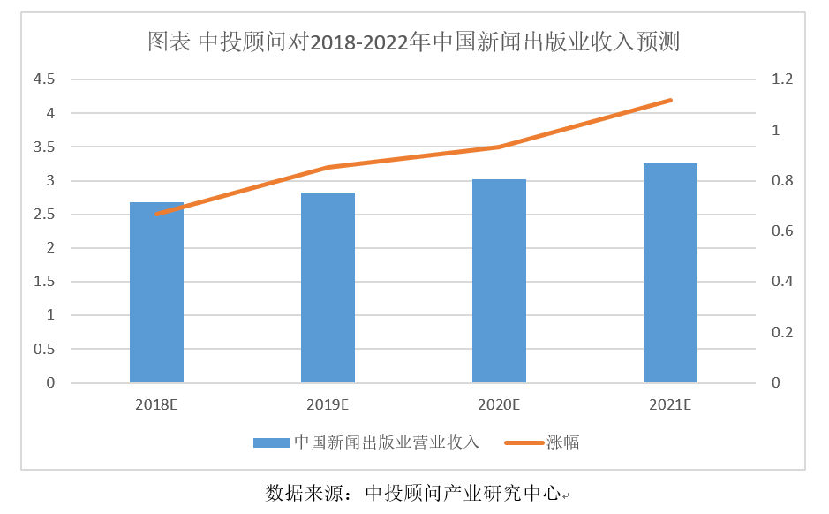

|  |  |
| --- | --- |
| 图表 中投顾问对2018-2022年··· | Figure. Consultant forecasts for the China News Publication Industry’s Revenue from 2018 to 2022 |
| 中国新闻出版业营业收入 | China News Publication Industry’s Revenue |
| 涨幅 | Growth |

2016年，我国新闻出版业营业收入为23,595.8亿元，同比增长8.96%。根据数据显示，我们预计，2018年我国新闻出版业营业收入将达到2.68万亿元，未来五年（2018-2022）年均复合增长率约为5.03%，2022年将达到3.26万亿元。

In 2016, China's press and publication industry revenue was 2,355.58 billion yuan, an 8.96% year on year increase. According to the data, we expect that China's press and publication industry revenue will reach 2.68 trillion yuan in 2018. With an average compound annual growth rate of 5.03% in the next five years (2018-2022), the market will reach 3.26 trillion yuan in 2022.

1. 传统教育产业现存痛点

The sore spots of traditional education industry

自教育行为可以转移到网络上以来，媒体和网络改变了教育的载体，教育形态的变更

使教育产业迎来新机遇。传统教育产业中，总是滞后的知识传递变得不合时宜，教链之前，也有众多从业者做出尝试，从在线教育到课程直播，都为这个行业带来了新的东西，但是传统教育中的弊端并没有因为表面的先进性而消失。

Since education behavior was transferred on-line, the media and network have changed the carriers of education. The changes in the forms of education have ushered new opportunities in the education industry. The always lagging knowledge transfer in the traditional education industry had become an anachronism. Before the emerging of the education chain, practitioners had made attempts, from online education to curriculum live, to bring something new to the industry. However, the disadvantages of traditional education did not disappear because of these progresses.

毋庸置疑的是，我们的确可以通过更为便捷的方式来学习，在地铁上你可以打开手机听一小节音频的课程，也可以足不出户参与世界名校的公开课等等，我们把这种因信息网络的繁荣所部分消弭的地域对于知识传播的阻碍称为教育产业的前期浅显性变革，换句话来说，此前的所有的教育产业尝试，都是在表现方式上做的创新，教育产业的核心所在并没有发生令人欣喜的进步，正如一部电影的无聊并不是因为放映机的品牌所导致的，教育产业所面临的问题也不是因为教学形式的不同所导致的。

There is no doubt that one indeed can learn in a more convenient manner: by listening to a section of audio course with his smart phone while he is taking the subway, or by attending on-line public curriculum offered by world renowned universities, etc. The prosperous information network has partially offset the geographical limitations on knowledge dissemination. These are shallow changes in the early stage. In other words, all the attempts made in the education industry are merely innovations in expression modes. The core of the education industry has not witnessed any promising progress. A boring film was not the fault of the brand of projector. Similarly, the problems in the education industry are not caused by the difference in teaching modes.

先来看看目前教育产业中一些已经暴露许久的问题：

First, let’s take a look at the long exposed problems in the education industry:

1. 学与用无法贯通：传统高校教学内容落后陈旧，与用人单位所需人才契合度太低。

What one has leaned cannot be put into practice: the teaching contents of traditional colleges and universities are backward and old, therefore are poorly aligned with the needs by employers.

1. 传统教育成本过高：传统教育宽泛而不专精，造成了选择成本和时间成本的激增。

Traditional education costs too much: traditional education is not exclusive, resulting in rocketing cost of choice and time.

1. 学生学习动力与黏性差：学生学习靠自觉，没有利益激励，造成学习动力低下，黏性弱。

Poor learning motivation and stickiness: without interest incentive, students rely on self-consciousness in learning, resulting in low learning motivation and weak stickiness.

1. 内容创作者版权无法保护：传统情况下无法存在一个跨平台且透明的版权监督机制

The copyright of content creators cannot be protected: there is no cross-platform and transparent copyright supervision mechanism under traditional circumstances.

1. 内容创造者价值无法激活：目前互联网无授权转载售卖泛滥，导致内容创造者权益受损，创作动力降低。

The value of content creators cannot be activated: at present, unauthorized reproduction and sales are rampant on the Internet. This has undermined the rights and interests of content creators and discouraged their creation.

1. 教育者信用体系缺失：频繁曝出的幼师素质问题，以及高等教育者信用缺失。

The lack of education credit system: the frequent exposure of low quality kindergarten teachers, as well as the lack of higher education credit.

1. 无法建立精准的人才数据系统：现存的简历系统、学历系统都无法准确且真实的体现人才的价值与能力。

It is impossible to establish an accurate talent data system: the existing resume and education background system cannot accurately and truly reflect the value and ability of talents.

1. 传统教育中心化集权：传统教育模式以单一学校为中心，严重阻隔数据的公开和价值的流通。

The centralization of traditional education: the traditional education mode is centered on individual schools, which seriously blocks the disclosure of data and the circulation of value.

1. 数据的寡头化：在目前的情况下，个体的数据被教育寡头、招聘寡头垄断价值。

Data oligopoly: Currently, the value of individual data is monopolized by education and employment oligopoly.

1. 数据交换难安全：个人数据泄漏严重，各寡头数据库庞大，并且不断通过资本力量扩大。

Data exchange is difficult to secure: the personal data leakage is serious, the oligarch database is huge and is continuously expanding with capital power.

1. 声誉评价难综合：社会对于个体的评价难以集中，无法做到透明真实。

Reputation evaluation is difficult to be integrated: it is difficult for the society to integrate individual evaluations and achieve transparency and authenticity.

1. 数据的零散化：数据以产业为核心却不以人为核心。

Data fragmentation: data is industry-centric but not human-centric.

正如你不可能通过改变椟的材质来增加珠的价值，以上所有问题也都不能被形式的先进而改变。

As you can't increase the value of beads by changing the case’s material, all these problems can not be addressed by advanced education modes.

但是随着去中心化思想的共识人群不断扩大，比特币、以太坊等数字资产的价值不断获得市场的认同，我们惊喜的发现，教育产业的核心也即将迎来一次深刻的脱胎换骨。

However, as the population with consensus of decentralized ideas expands, the value of digital assets (e.g., Bitcoin, Ethereum) is increasingly recognized by the market. The core of education industry will witness a fundamental change.

1. **教链（JLL）创新与变革**

**JLL's innovation and changes**

1. 变革的核心

The core of change

区块链去中心的应用，实现跨行业重新定义，使得内容创造者、学生、教培机构、用人单位各方交易结构发生变化，省去过去中间环节，降低教育行业的信息不对称及信用成本，在Tokens（代币）激励下实现利益的合理分配；

The decentralized applications based on block chain will achieve cross-industry redefinition. The exchange structure among content creators, students, education training organizations, and employers will be transformed to abrogate intermediate links. As a result, the information asymmetry will be mitigated and credit cost reduced. The rational distribution of interests will be achieved with token incentives;

1. 利用技术重塑市场模型

Reshape market models with technology

透过Token与DAPP经济模型和规则，使得内容创造者、学生、教培机构、用人单位各方行为背后都是经济行为，通过区块链分布式智能合约协议，重塑跨行业交易信任机制；

Through token and DAPP economic models and rules, content creators, students, education organizations and employers will behave economically. The cross-industry trade trust mechanism will be reshaped by implementing distributed smart contract protocol of block chain;

1. 行为的定义

Definition of behavior

内容创造者、学生、教培机构、用人单位利用DAPP可以创造价值，通过共识算法的量化与认证以实现奖励机制的落实。在用户学习量、内容创造量等行为背后，构建与之关联的Token经济体系，从而实现收益合理分配；

Content creators, students, educational organizations and employers can create value by using DAPP, and implement the incentive mechanism through the quantification and certification of consensus algorithm. A token economy system associated with user behaviors (e.g., learning and content creation) will be constructed to realize rational income distribution;

1. 教育产业区块链变革结果

The results of education industry block chain changes

基于DAPP去中心化跨领域应用，使得教育产业变革成为可能。

The decentralized and cross-section applications based on DAPP will enable the changes in the education industry.

我们期待的变革结果：在区块链分布式的生态体系当中，通过JLL智能协议，实现跨领域交易的技术重塑，通过合理Token激励与收益分配的机制驱动，推动教育产业链的一切都将以最合理的方式运转。所有的中间环节，将大量被自动化的智能合约所代替，效率将大幅提升；同时各种不必要的干扰和价值损耗，也将被最大可能地消除，各方通过行为角色重塑，满足各方需要，价值也将必然的以合理的方式回报。

The desired results are as follows: the cross-section trade technology will be reshaped by implementing JLL smart contract in the distributed block chain ecosystem; all the links in the education industry chain, driven by token incentives and income distribution, will operate in the most reasonable manner. The efficiency of the industry chain will improve remarkably as all the intermediate links will be replaced by large number of automated smart contracts; at the same time, all kinds of undesired interference and value losses will be mitigated as much as possible; all parties will meet each other’s demands by reshaping their behavioral roles, and value will be definitely rewarded in a rational way.

1. **教链（JLL）技术体系**

**JLL’s technology system**

利用区块链分布式技术突破行业壁垒，通过JLL智能协议获得规则定义的能力，实现教育行业利益分配规则的改变。

The industry barriers will be broken through by using distributed block chain technology; besides, one will be enabled to define the rules by implementing JLL smart contract, so as to reform the income distribution rules in the education industry.

1. 技术体系

Technology system

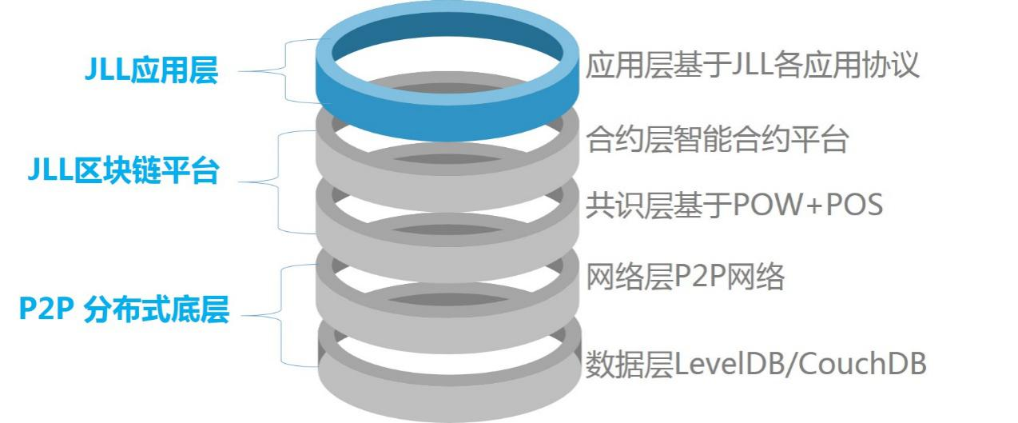

|  |  |
| --- | --- |
| JLL应用层 | JLL Application Layer |
| JLL 区块链平台 | JLL Block Chain Platform |
| P2P 分布式底层 | P2P Distributed Base Layer |
| 应用层基于JLL各应用协议 | The application layer is based on the various application protocols of JLL |
| 合约层智能合约平台 | The contract layer is based on smart contract platform |
| 共识层基于POW+POS | The consensus layer is based on POW+POS |
| 网络层P2P网络 | The network layer is based on P2P network |
| 数据层LevelDB/CouchDB | The data layer is based on LevelDB/CouchDB |

教链JLL的整体技术体系中，不出意外的选用分层疏离的运行方式，将应用层和数据层进行分离，利用前置协议规避了公链上诸多运用的同步升级与特异性升级。

Layered structure will be adopted in the overall technology system of JLL. The application layer and the data layer will be separated from each other. The synchronous and specific updates of the applications on public chain will be avoided by using preliminary protocol.

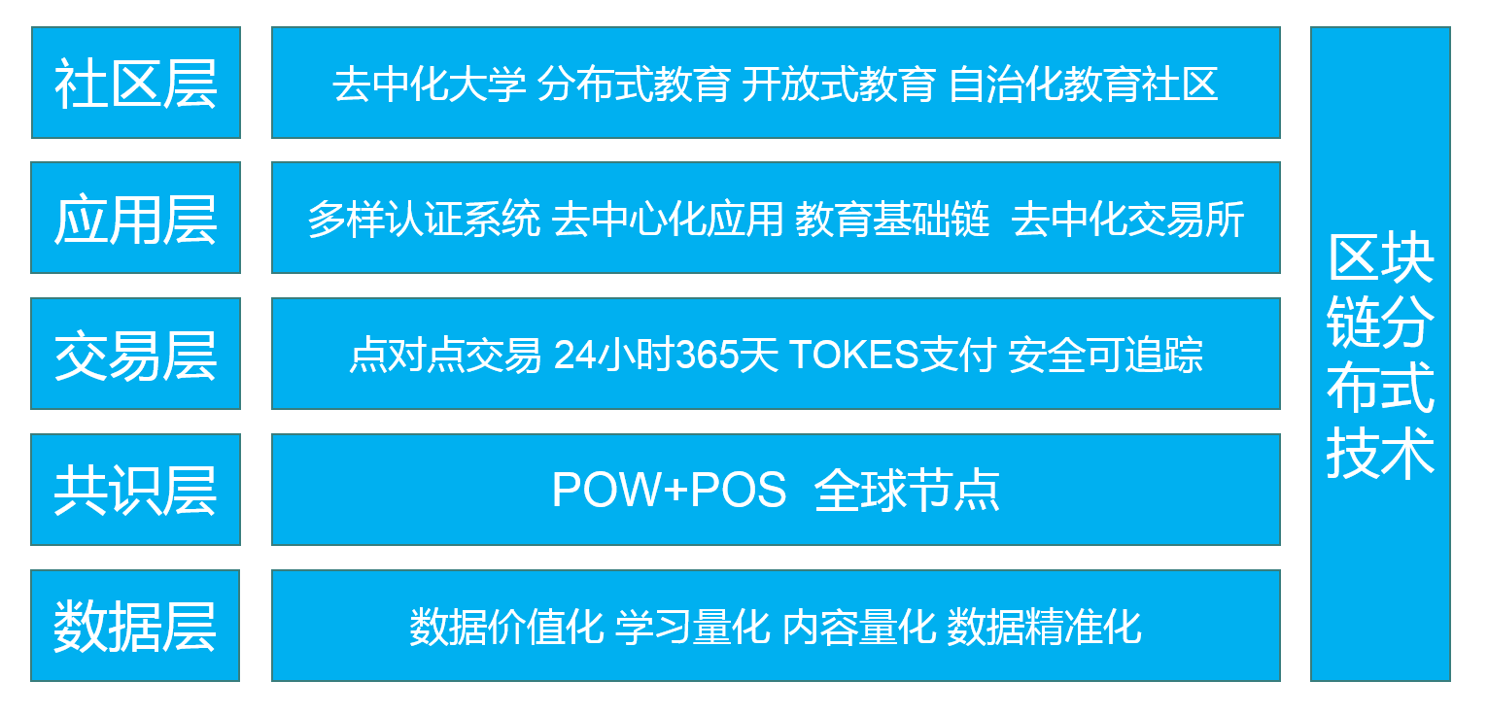

|  |  |  |
| --- | --- | --- |
| Community layer | Decentralized university, distributed education, open education, autonomous education community | Distributed block chain technology |
| Application Layer | Multiple certification system, decentralized system, education basic chain, decentralized exchange |
| Trade layer | P2P trade, 24h/365d token payment, security and traceability |
| Consensus layer | POW+POS global nodes |
| Data layer | Valuable data, quantified learning and contents, accurate data |

在我们的设计中，共识层与网络层也将处于不同层级，共识层所有的POW+POS的Token激励机制将不会影响到P2P网络的稳定性。

In our design, the consensus layer and the network layer will also be at different levels. All the POW+POS token incentive mechanism owned by the consensus layer will not affect the stability of P2P network.

1. 应用信任体系

Application trust system

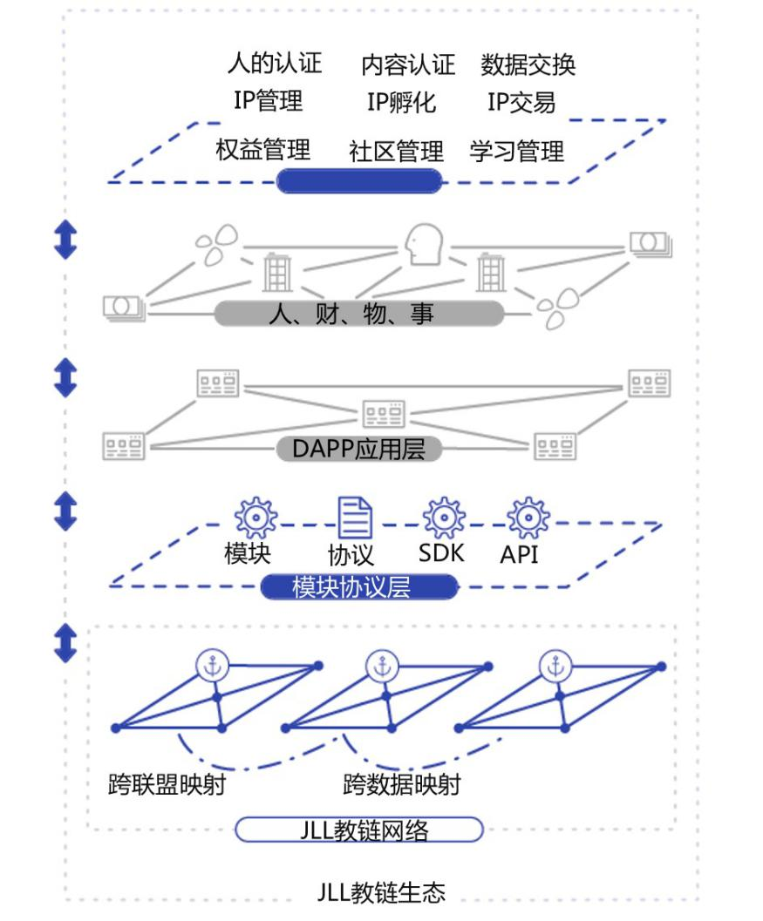

|  |  |  |  |  |  |
| --- | --- | --- | --- | --- | --- |
| People certification | | Content certification | | Data exchange | |
| IP management | | IP hatch | | IP exchange | |
| Rights management | | Community management | | Learning management | |
| People, property, objects, things | | | | | |
| DAPP application layer | | | | | |
| Module | Protocols | | SDK | | API |
| Module protocol layer | | | | | |
| Cross-alliance mapping | | | Cross data mapping | | |
| JLL network | | | | | |
| JLL ecosystem | | | | | |

创新融合的一体的分布式信任网络协议和教育信用生态的基础设施连接器。JLL信任网络是一个多方基础应用、多生态融合的教育协议网络，来自不同各方和系统可以支持不同的教育垂直业务体系，并通过JLL协议进行协作。

We have created an integrated infrastructure connector for the distributed trust network protocol and the education credit ecosystem. The JLL trust network is an education protocol network integrating basic applications and ecosystems from multiple parties. The vertical education business systems are supported by applications and systems from different parties, and are coordinated through the JLL protocol.

架构体系进行模块化、可插拔、灵活扩展的松耦合设计，以支持不同业务领域的需求，可以灵活扩展到各类业务应用支持；

The architecture system provides loosely-coupled design which is modular, pluggable, and flexibly extensible, so as to support the needs of different business sectors. Such design could be flexibly extended to support various business applications.

教链协议网络将始终结合区块链/分布式账本领域相关技术的发展、教育垂直生态领域的应用，提供分布式账本、智能合约、分布式实体管理认证协议、分布式数据交换协议等一系列的协议基础层与应用接口，任何应用服务提供方无需分布式底层开发能力，可以直接基于教链协议提供分布式服务。

The education chain protocol network will always combine the development of relevant block chain/distributed ledger technologies with the applications in vertical education ecosystem applications. It will provide a number of interfaces at the protocol’s basic and application layers, such as distributed ledger, smart contracts, distributed entity management and authentication protocols, and distributed data exchange protocols, etc. Any application provider will be enabled to directly offer distributed services based on the education chain even if they don’t have the capability to develop distributed layers.



教链（JLL）是以认证源的有效协同、数据源的互相连通、各类分布式应用服务底层技术等为基础的新型信任体系，可以将它理解为可以囊括人才与内容的超大版权共识信任体系。教育工作者将教学内容上传到LevelDB/CouchDB底层数据中，包括文字、音频、视频等所有可储存流媒体元素，上传完成后将媒体信息的特征做编码，生成全网唯一却不可篡改的加密编码。于是在JLL的区块系统中记录的数据具有严格的时序以及码序，如发生著作权冲突，系统可以根据时序加密编码进行审核，同时可以确定最终版权归属。如果发布了侵权内容，系统会如实记录发布时间、发布者及内容。

As a new trust system built on the effective coordination of authentication sources, the connectivity of data sources, and the underlying technologies of various distributed services, JLL could be described as a huge consensus trust system covering talents and contents. Education workers will upload the teaching contents to the underlying database of LevelDB/CouchDB, including text, audio, video, and all storable streaming media elements. After the completion of the upload, the characteristics of media information will be coded to generate encrypted codes which are unique and tamper-proof across the network. As a result, the data recorded in the JLL block chain system are strictly sorted in terms of both time and code. In the case of any copyright conflict, the system will review the chronological encryption codes and determine the final ownership at the same time. Whenever any infringing content is published, the system will accurately record the time of publication, the publisher and the content.

流媒体作品，版权信息，操作记录均存储在LevelDB/CouchDB底层数据中且不可被篡改，这将从根本上保护教育内容者的利益，并有助于激发他们的分享和流通热情。超大版权信任体系致力于建立一个系统化的、流程化的、一体化、可量化的版权信任生态模型。

Streaming media works, copyright information, operation logs are stored in the underlying database of LevelDB/CouchDB and will not be tampered. It will fundamentally protect the interests of the education content creators, and help to stimulate their enthusiasm to share and circulate. The super-large copyright trust system is committed to establishing a systematic, streamlined, integrated and quantifiable copyright trust ecological model.

基于此，教链将作为教育信任生态体系的基础设施和连接器造福各个教育垂直领域。完善各类教育场景的基础设施。

Based on this, the education chain will serve as the infrastructure and connector of education trust ecosystem to benefit the vertical education sector. Meanwhile, it will improve the infrastructure of various education scenarios.

1. 技术架构

The Technical Architecture

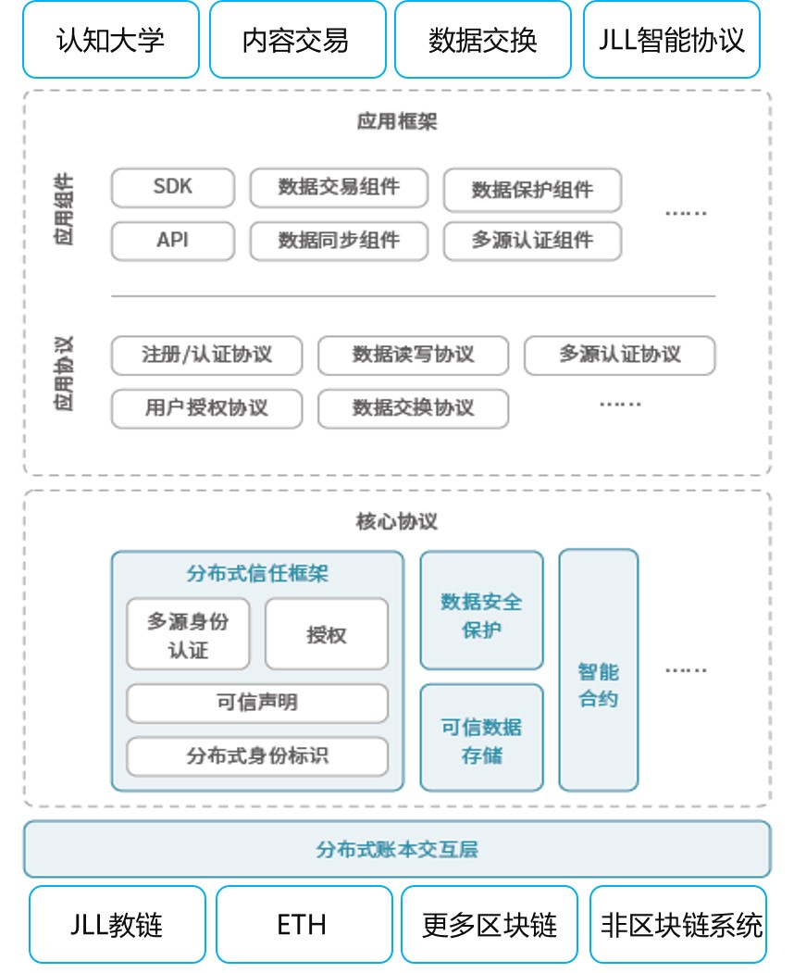

|  |  |  |  |
| --- | --- | --- | --- |
| Cognition university | Content exchange | Data exchange | JLL smart contract |
| Application framework | | | |
| Application components | SDK | Data exchange components | Data protection components |
| API | Data synchronization components | Multi-source certification components |
| Application protocol | Register/certification protocol | Data read and write protocol | Multi-source certification protocol |
| User authorization protocol | Data exchange protocol |  |
| Core protocols | | | |
| Distributed trust framework | | Data security and protection | Smart contract |
| Multi-source identify certification | Authorization | Trust-worthy data storage |
| Trust statement | |  |  |
| Distributed identity marker | |  |  |
| Interaction layer of distributed ledger | | | |
| JLL | ETH | More block chains | Non-blockchain systems |

教链（JLL）提供了完整的分布式数据记录体系，囊括了目前最新的智能合约体系以及数据安全体系。同时，教链对底层统计算法的技术体系及异构的系统进行了统一，实现了兼容各类协议、密码标准、分布式实体管理、多维认证协议的功能。并且支持对各类异构区块链和传统信息系统的跨链、跨系统的交互映射。还提供了诸如安全数据存储、异构智能合约、硬件密钥管理、加密数据分析的技术体系。整个教链网络作为一个应用平台可以支持构建各种应用服务，特别是去中心化应用。

JLL provides a complete distributed data recording system, including the latest smart contract system and data security system. At the same time, JLL has unified the technical system of underlying statistical algorithms and the heterogeneous systems, so as to be compatible with various kinds of protocols, encryption standards, distributed entity management, and multi-dimensional authentication functions. It supports cross-chain and cross-system mapping of heterogeneous block chains and traditional information systems. It also provides technical systems such as secure data storage, heterogeneous smart contracts, hardware key management, and encrypted data analysis. As an application platform, the entire education chain network can support the construction of various application services, especially decentralized applications.

在此基础之上，教链还提供了一系列包括应用框架、分布式数据交换协议、分布式流程管理协议等等，通过通用API、SDK以及各种应用功能组件，从根本上解决各类上层应用之间的互联互通。

On this basis, JLL also provides a series of services, including application frameworks, distributed data exchange protocols, distributed process management, etc. It will fundamentally address the connectivity between upper layer applications by using API, SDK and a variety of application components.

1. 多样认证体系

Multiple Certification System

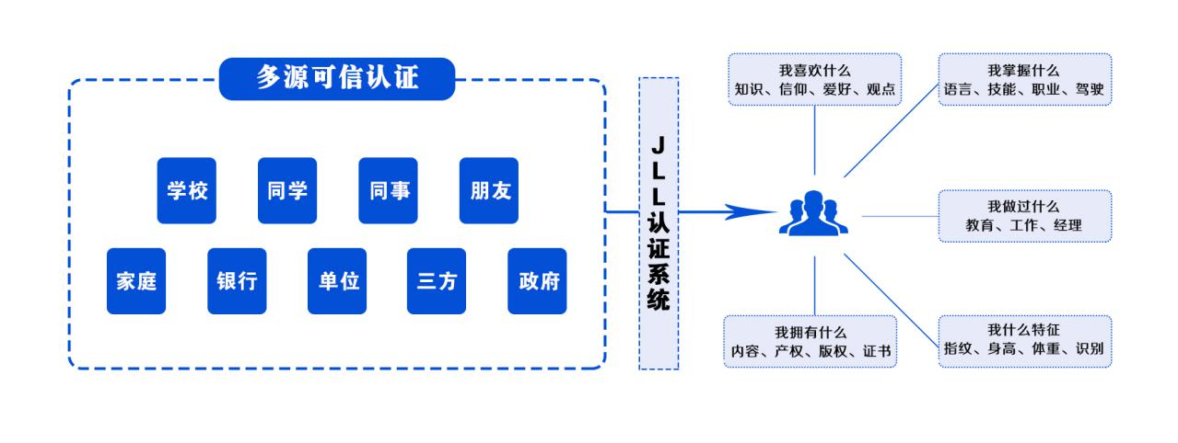

|  |  |
| --- | --- |
| 多源可信认证 | Multi-source trust certification |
| 学校 | Schools |
| 同学 | Classmates |
| 同事 | Colleagues |
| 朋友 | Friends |
| 家庭 | Family |
| 银行 | Banks |
| 单位 | Companies |
| 三方 | 3rd parties |
| 政府 | Government |
| JLL认证系统 | JLL certification system |
| 我喜欢什么··· | What do I like? Knowledge, belief, hobbies, views |
| 我掌握什么··· | What do I have? Language, skills, professions, driving |
| 我做过什么 | What have I done? Education, job, manager |
| 我拥有什么··· | What do I own? Contents, properties, copyrights, certificates |
| 我什么特征··· | What are my characteristics? Fingerprint, height, weight, identity. |

现代社会中人的社会关系图谱会越来越来庞杂，每个人都会与有多种社会关系互相交错，任何与个人有关联的组织或机构都掌握着与这个人有关的信息。通过教链，用户可以链接与授权所有与自己有关的教育相关数据。从政府机构到学校、银行等各种企事业单位，从家人、朋友到同事、领导、合作伙伴等个人均可成为认证的数据源，并在隐私和授权保护下实现一体化的灵活应用。全方位实现多源身份认证，完整的个人受教育情况画像，无法篡改且可信的数据追踪。

The interpersonal relationship map in modern society will become more and more complex. Everyone will interact with a variety of social relations. Therefore, any organization or institution associated with anyone will possess the information related to him/her. Through the education chain, users can link and authorize all education data related to themselves. Enterprises and institutions (e.g., government organs, schools to banks), and individuals (e.g., family members, friends, colleagues, leaders, and partners, etc.) will become certified data sources, which will be flexibly utilized in an integrated manner under the protection of privacy and authorization. With multi-source authentication in all aspects and complete personal education portrait, the data tracking will not only be tamper-proof, but also trustworthy.

1. 数据交换体系

Data transaction system

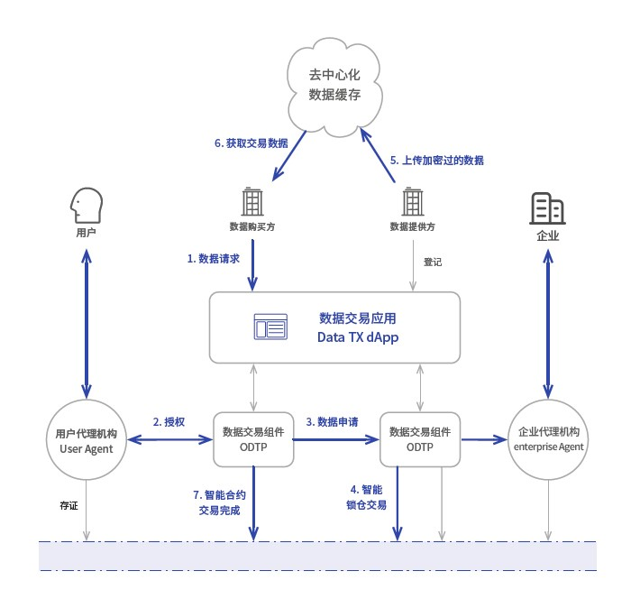

|  |  |
| --- | --- |
| 去中心数据缓存 | Decentralized data cache |
| 获取交易数据 | Acquire exchange data |
| 上传加密过的数据 | Upload encrypted data |
| 数据购买方 | Data buyer |
| 数据提供方 | Data provider |
| 数据请求 | Data request |
| 等级 | Registration |
| 数据交易应用 | Data exchange application |
| 用户代理机构 | Users agent |
| 数据交易组件 | Data exchange components |
| 授权 | Authorization |
| 数据申请 | Data application |
| 企业代理机构 | Enterprise agent |
| 存证 | Deposit certificate |
| 智能合约交易完成 | Smart contract exchange completed |
| 智能锁仓交易 | Smart locking exchange |

1. 数据对接授权

Data access authorization

需要使用数据的应用不再需要逐一对接各数据源，而是直接通过用户授权，根据用户身份ID申请授权对接访问用户的数据。借此，数据使用者可以发现更多维度的教育数据、更大规模的数据，实现充分了解用户，为用户提供更有针对性的课程或服务和产品的功能。

Applications that need to use data are no longer required to connect to data sources one after another. Instead, they will access users’ data directly by applying for authorization according to user ID. Whereby users can find more dimensions of the education data in a larger scale. In this sense, they will be able to fully understand the users, so as to provide more specific courses or service and product features.

1. 数据交易模型

Data exchange model

数据使用方通过用户身份ID检索到用户数据的访问地址，发出获取数据的请求。请求将首先发送到用户的客户端，由用户进行确认并授权。只有通过用户授权的请求才能进一步处理。教链的设计让用户（数据生产者）可以充分获得数据服务的知情权和收益权。

The using party retrieves the access address of user's data through the latter's identity ID and requests to get the data. The request is firstly sent to the user's client for confirmation and authorization. Only requests authorized by the user can be further processed. The education chain is designed to enable users (e.g., data producers) to obtain the right to be informed and to earnings.

1. 海量存储

Mass storage

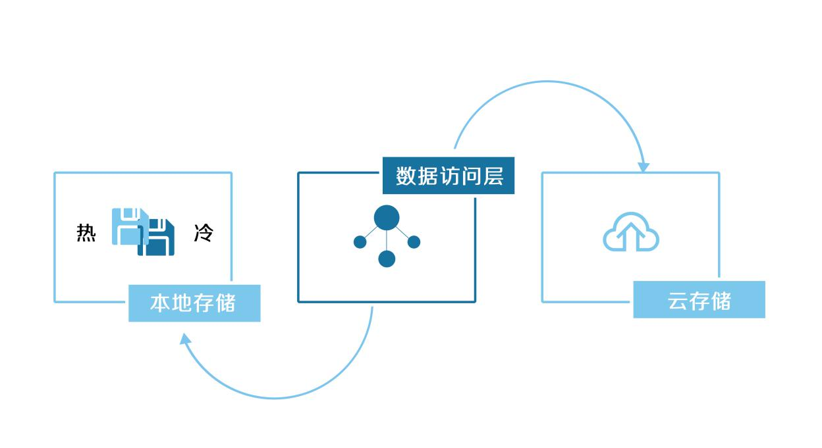

|  |  |
| --- | --- |
| 冷 | Cold storage |
| 热 | Hot storage |
| 本地存储 | Local storage |
| 数据访问层 | Data access layer |
| 云存储 | Cloud storage |

IPFS是一个对等的分布式文件系统，它尝试为所有计算设备连接同一个文件系统。在某些方面，IPFS类似于万维网，但它也可以被视作一个独立的BitTorrent群、在同一个Git仓库中交换对象。换种说法，IPFS提供了一个高吞吐量、按内容寻址的块存储模型，及与内容相关超链接。这形成了一个广义的Merkle有向无环图（DAG）。IPFS结合了分布式散列表、鼓励块交换和一个自我认证的命名空间。IPFS没有单点故障，并且节点不需要相互信任。分布式内容传递可以节约带宽，和防止HTTP方案可能遇到的DDoS攻击。

IPFS is a peer-to-peer distributed file system that tries to connect all computing devices to the same file system. IPFS is similar in some ways to the World Wide Web, but it can also be thought of as a separate BitTorrent group, exchanging objects in the same Git repository. In other words, IPFS provides a high throughput, content-addressable block storage model, and content-related hyperlinks. This forms a generalized Merkle Directed Acyclic Graph (DAG). IPFS combines distributed hashtables, encouraging block exchange and a self-validating namespace. IPFS has no single point of failure, and its nodes do not need to trust each other. Distributed content transmission can save bandwidth and prevent DDoS attacks that HTTP solutions might encounter.

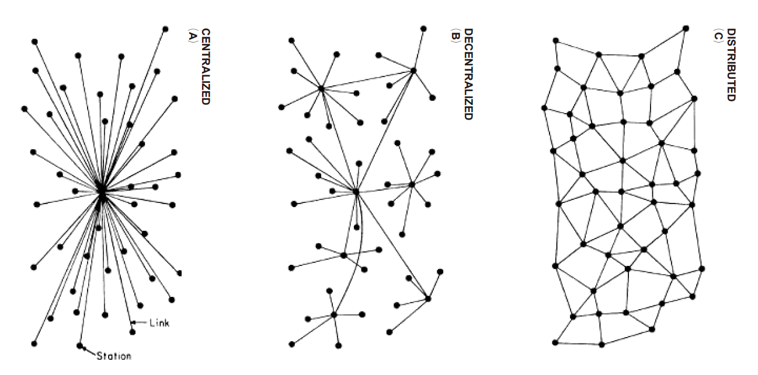

强大网络数据的分发机制：

Powerful network data distribution mechanism:

哈希指纹是指每个文件及其包含的所有数据块，都会转换为一个散列字符串。每个节点维护一张DHT（分布式哈希表），包含相应数据块与目标节点的对应映射关系。整个哈希表被组织成二叉树，平均查询联系节点的复杂度是O(log2N)。例如要查询10000万节点只需20跳。基于内容寻址而非域名寻址。只需要通过文件或数据块的哈希值，IPFS便可自动在全网节点中找到拥有这些数据块的节点，并从节点上拉去数据。IPFS使用一个叫IPNS的分布式命名系统，将难于记忆的数据哈希值映射为易于记忆的字符串。这可以类比于域名与IP地址的映射关系。

A hash fingerprint refers to each file and all the data blocks it contains, which will be converted to a hash string. Each node maintains a DHT (distributed hash table) containing the corresponding mapping relation between the data block and the target node. The entire hash table is organized into a binary tree, and the average complexity of querying the contact nodes is O(log2N). For example, it only takes 20 hops to query 10,000 nodes. Addressing is based on contents rather than domain names. IPFS automatically finds the nodes with the blocks in the whole network and pulls the data off the nodes by simply using the hash values of the files or data blocks. IPFS uses a distributed naming system called IPNS to map hard-to-remember data hash values to easy-to-remember strings. This is analogous to mapping a domain name to an IP address.

IPFS具有如下一些特性：

IPFS has the following features:

* 相同数据内容被赋予唯一的哈希指纹，通过哈希指纹的对比即可判断数据块是否一致;
* 节点本身使用类似git的版本控制系统，来管理本地文件与数据块。这既保证了数据块的去冗余，又提供了可追溯的历史版本;
* IPFS节点在维护哈希路由表、账本一致性方面，需使用区块链技术，一方面是在动态增减内容、节点方面与全网达成共识； 另一方面是为激励机制中JLL TOKEN发行与账本管理建设基础平台;
* 通过发行JLL TOKEN来激励节点存储稀有的数据块。节点不仅可从其他节点拉取所需数据，同时也可将该新数据存储在自己节点，供其他节点下载。
* The same data content is given a unique hash fingerprint, One can judge whether the data blocks are consistent by comparing the hash fingerprint.
* The node itself uses a version control system similar to git to manage local files and data blocks. This not only ensures the de-redundancy of data blocks, but also provides a traceable historical version.
* IPFS nodes need to use block chain technology to maintain the consistency of hash routing tables and accounts. On the one hand, it reaches consensus with the whole network in terms of dynamic increase and decrease of content and nodes. On the other hand, it is a basic platform for JLL TOKEN issuance and accounting management in JLL incentive mechanism.
* Nodes are encouraged to store rare data blocks by issuing JLL TOKEN. A node can not only pull the required data from its peers, but also store the new data in its own node for others to download.

IPFS 是一个基于内容和身份寻址的超媒体协议，不同于传统的位置寻址在IPFS协议的层面上，这个系统是完全传输中立的。这意味着节点可以在任意传输协议上运行。事实上，IPFS节点并不需要以一个中心化的IP作为参照。IPFS节点能在各种各样的网络体系结构中运行， IPFS是一个革新的范式转移分散存储。平台上的任何部分都不会储存到一个集中的服务器上。因此任何机构、任何人乃至教链JLL，都不能检查或限制创作者在IPFS平台上发布作品。身份信息的生成与验证节点通过NodeId唯一标识。它通常是使用S/kademlia的静态加密难题所创建的公钥。节点会存储它的公私钥对，用户可以在每次初始化时注册成为一个“新”节点，但这导致损失已积累的网络收益。

IPFS is a hypermedia protocol based on content and identity addressing. Unlike traditional location addressing at the IPFS protocol level, this system is completely transmission-neutral. This means that the node can run on any transmission protocol. In fact, IPFS nodes do not need to reference a centralized IP. IPFS nodes can run in a variety of network architectures, and is an innovative paradigm for transferring decentralized storage. No part of the platform is stored on a centralized server. As a result, no organization, no one, or not even the chain JLL, can check or restrict the release of a work by the creator on the IPFS platform. The identity information generation and verification node is uniquely identified by the NodeId. It is typically a public key created using the static encryption problem of S/kademlia. The node stores its public and private key pairs. Users can register as a "new" node each time they initialize it, but this results in the loss of the accumulated network benefits.

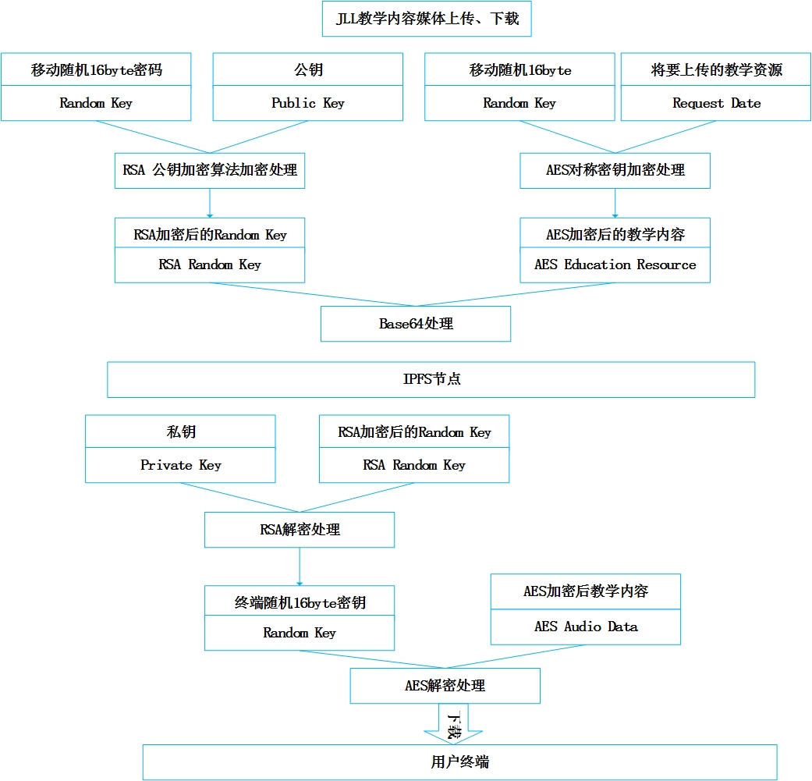

|  |  |  |  |
| --- | --- | --- | --- |
| Upload and download JLL teaching contents and media | | | |
| Random key 16 byte password | Public key | Random key 16 byte | Teaching contents to be uploaded |
| Encrypted by the RSA public key encryption algorithm | | AES symmetry encryption | |
| RSA encrypted public key | | AES encrypted teaching contents | |
| Base64 processing | | | |
| IPFS nodes | | | |
| Private key | RSA random key |  |  |
| RSA decoding | |  |  |
| Terminal random 16byte key | | AES encrypted teaching contents | |
| ASE decoding | | | |
| Download | | | |
| User terminal | | | |

*type NodeId Multihash*

*type Multihash []byte // 自描述加密哈希摘要*

*type PublicKey []byte*

*type PrivateKey []byte // 自描述的私钥*

*type Node struct {*

*NodeId NodeID*

*PubKey PublicKey*

*PriKey PrivateKey*

*}*

*difficulty = <integer parameter>//基于S / Kademlia的IPFS身份生成：*

*n = Node{}*

*do {*

*n.PubKey, n.PrivKey = PKI.genKeyPair()*

*n.NodeId = hash(n.PubKey)*

*p = count\_preceding\_zero\_bits(hash(n.NodeId))*

*} while (p < difficulty)*

第一次连接时，对等节点交换公钥并检查：对方的NodeId是否等于公钥的哈希值。

若否，则终止连接。

*type NodeId Multihash*

*type Multihash []byte // self-described encryption hash summary*

*type PublicKey []byte*

*Type PrivateKey []byte // / self-described PrivateKey*

*type Node struct {*

*NodeId NodeID*

*PubKey PublicKey*

*PriKey PrivateKey*

*}*

*Difficulty = <integer parameter>// IPFS identity generation based on S/Kademlia:*

*n = Node{}*

*do {*

*n.PubKey, n.PrivKey = PKI.genKeyPair()*

*n.NodeId = hash(n.PubKey)*

*p = count\_preceding\_zero\_bits(hash(n.NodeId))*

*} while (p < difficulty)*

At the first connection, the peer nodes exchange the public key and check if the NodeId of the peer is equal to the hash value of the public key.

If not, the connection is terminated.

1. 海量IP数据存储

Massive IP data storage

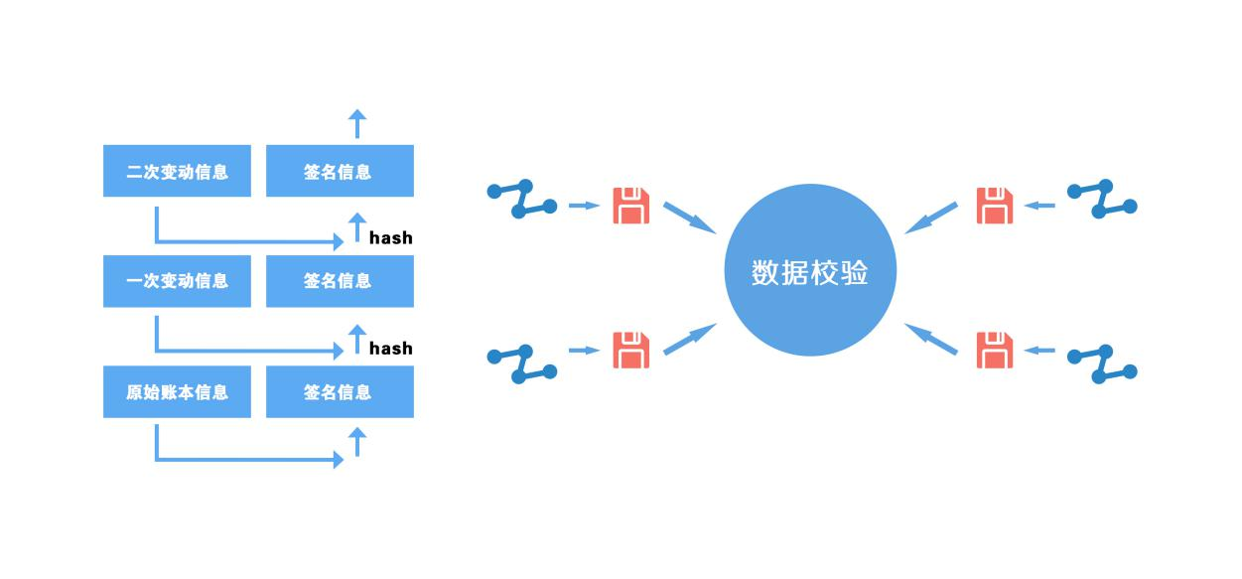

|  |  |
| --- | --- |
| 二次变动信息 | Secondary change information |
| 签名信息 | Signature information |
| 一次变动信息 | Primary change information |
| 原始账本信息 | Original Ledger information |
| 数据校验 | Data verification |

JLL教链区块链通过非对称加密的数字签名的技术，做到了业务请求在传输过程中不被篡改，并且通过共识机制保证各节点的数据一致。对于已经存储的数据记录则通过节点内的自校验系统和准实时多节点系统来校验，以保证已经存储的数据记录同样无法篡改。

JLL block chain ensures that business requests are not tampered in the transmission process through asymmetric encryption of digital signature technology, and guarantees the data consistency of all nodes through a consensus mechanism. For the stored data records, the self-verification system and the quasi-real-time multi-node system in the nodes are used to verify them, so as to ensure that these records cannot be tampered with.

节点的自校验性是指JLL教链区块链采用块链结构存储数据记录，其中篡改数据会破坏块链结构的完整性，系统可以快速校验出来并从其他节点将数据恢复。另外JLL教链区块链每个记账节点都有自己的私钥，每个区块中记录了本节点私钥的签名，区块内数据的修改都可以通过签名校验出来。

By self-verifying nodes, JLL block chain stores data records by using chain structure. The integrity of chain structure will be undermined by tampered data, which will be quickly verified and recovered from other nodes. In addition, each billing node of JLL block chain has its own private key. The signature of this node's private key is recorded in each block, and the data modification in the block can be verified by signature.

准时多节点的数据校验：当节点的私钥被盗取，恶意用户是存在修改账本链上所有数据的可能性的，教链JLL区块链提供了准时多节点的数据对比机制，可以及时发现某个节点账本数据被篡改的情况。

Punctual multi-node data verification: when the private key of a node is stolen, the malicious user will probably alter all the data on the ledger chain. JLL block chain provides a punctual multi-node data contrast mechanism, which can timely detect the tampering of a node’s ledger data.

1. **教链（JLL）解决方案**

**JLL solution**

教链（JLL）教育产业公有链平台&分布式教育生态，基于“开源、开放、开心”的理念,将搭建区块链基础设施，并开放内部能力，与行业共治、共享，共同推动教育生态的发展，打造去中心化的多方共赢生态。

The education chain (JLL), a public chain platform & distributed ecosystem for the education industry based on the concept of "open source, openness, and happiness", will construct block chain infrastructure and open its internal capabilities to promote the development of a multi-win-win ecosystem by joint governance and sharing with the education industry.

1. 教链（JLL）社区部落

Education chain (JLL) community tribe

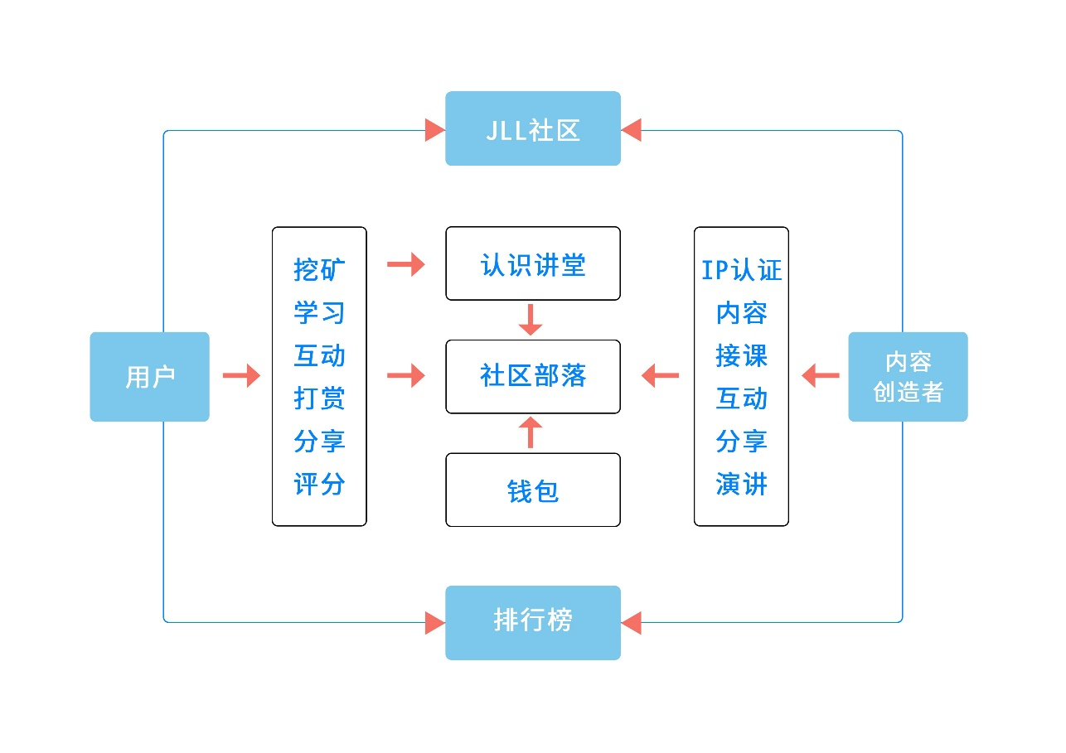

|  |  |
| --- | --- |
| JLL社区 | JLL community |
| 用户 | Users |
| 内容创造者 | Content creators |
| 排行榜 | Ranking |
| 挖矿、学习··· | Mining, learning, interaction, rewarding, sharing, rating |
| 认识讲堂 | Cognition lecture |
| 社区部落 | Community tribe |
| 钱包 | Wallet |
| IP认证、内容··· | IP certification，contents, curricula, interaction, sharing, lecture |

教链的整个生态由用户、认知讲堂、教链社区、挖矿和排行五大要素构成。用户构成教链社群，可以通过挖矿机制来获取教链代币，以及其他和教链有战略合作关系的其他项目代币。挖矿是教链代币获取的一种方式，也是整个生态的重要组成部分。在教链社区中，有很多有趣的共建方式：教师以认知讲堂作为其个人及其教学内容的展示平台，将自己的教学相关内容上传至认知讲堂，社群用户可以用代币来为喜欢的教学工作者及其内容投票，也可用代币对教师及其内容进行打赏。社群会依据投票情况，为教师及其所传内容进行排名，促进其获取用户打赏以及社群激励。

The whole ecosystem of JLL consists of five elements: users, cognition lectures, education chain community, mining and ranking. A community comprises of users, who obtains tokens through mining mechanism and other programs with which JLL has forged strategic partnership. Mining is one of the ways to obtain tokens and an important part of the whole ecosystem. There are a lot of co-building manners in the community: a teacher will use the cognition lecture as the platform to demonstrate himself and his teaching contents--he will upload related contents to the cognition lecture. Community users vote for or reward the preferred educators and their contents with tokens. The community will rank the teachers and their contents based on the votes, motivating the teachers to obtain user rewards and community incentives.

1. 教链（JLL）DAPP应用

JLL DAPP applications

教师和教培机构通过JLL协议实现其各类教学内容，如课程、书籍、音频等的上链认证，教培机构可以通过JLL协议及其认证，发现并购买教师所提供的教学内容；人才也可以享受经JLL多样认证的、由教师和教培机构所提供的各类教学内容。所有的交易、培训及教学内容信息均由分布式账本进行数据存储，企业可向人才发出验证请求，获取其在平台上所记录的各类信息，获取其教育相关的全面画像，为其用人选聘提供决策支持。

Teachers and education organization realize all kinds of teaching contents, such as the certification of courses, books, audio and others, through JLL protocol; an education organization find and purchase the teaching contents provided by teachers through JLL protocol and its certification; talents can also enjoy a variety of JLL certified teaching content provided by teachers and educational organizations. All transactions, training and teaching content information are stored as data on distributed ledgers. A company can send a validation request to a talent. By doing this, the company gets all his information recorded on the platform, accesses to his comprehensive education portrait, and supports the decision making of employment.

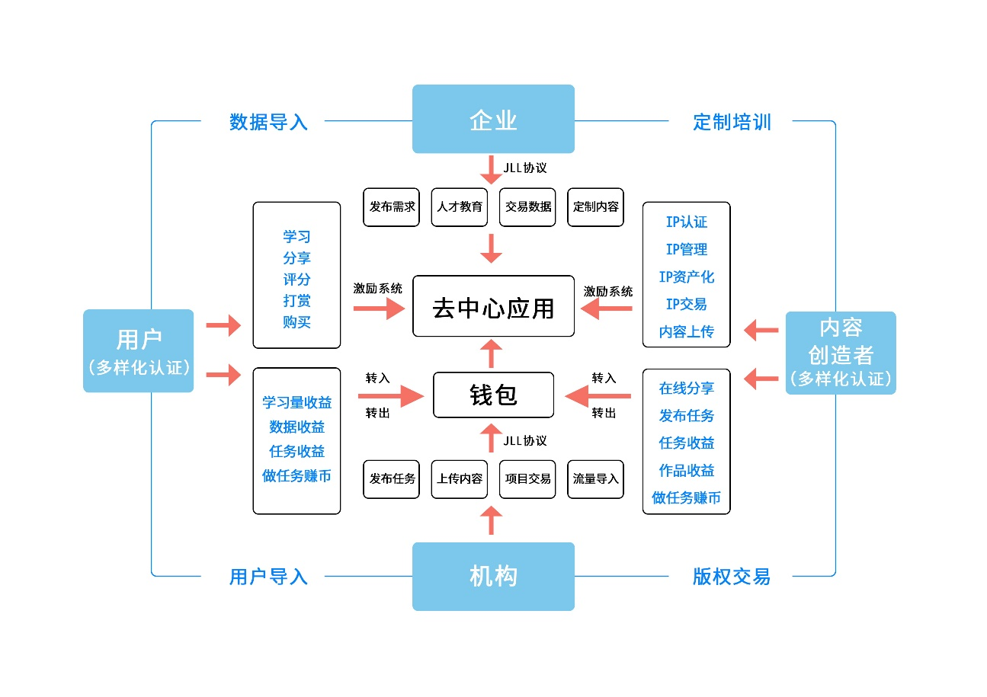

|  |  |
| --- | --- |
| 企业 | Businesses |
| 用户(diverse certification) | Users(diverse certification) |
| 内容创造者 | Content creators(diverse certification) |
| 机构 | Education organizations |
| 用户导入 | Users induction |
| 数据导入 | Data input |
| 定制培训 | Customized training |
| 版权交易 | Copyright transaction |
| JLL协议 | JLL protocol |
| 发布需求 | Release demands |
| 人才教育 | Talent education |
| 交易数据 | Transaction data |
| 定制内容 | Customized contents |
| 去中心应用 | Decentralized application |
| 钱包 | Wallet |
| 学习、分享··· | Learning, sharing, rating, rewarding, purchasing |
| IP认证、IP管理··· | IP certification，IP management, IP asset, IP transaction, content uploading |
| 学习量收益·· | Learning earning, data earning, task earning, earn tokens by completing tasks |
| 在线分享··· | On-line sharing, task releasing, task earning, work earning, earn tokens by completing tasks |
| 转入 | In |
| 转出 | Out |
| 发布任务 | Release tasks |
| 上传内容 | Upload contents |
| 项目交易 | Project transaction |
| 流量导入 | Traffic induction |

1. 教链（JLL）人才、内容交易所

JLL exchange for talents and contents

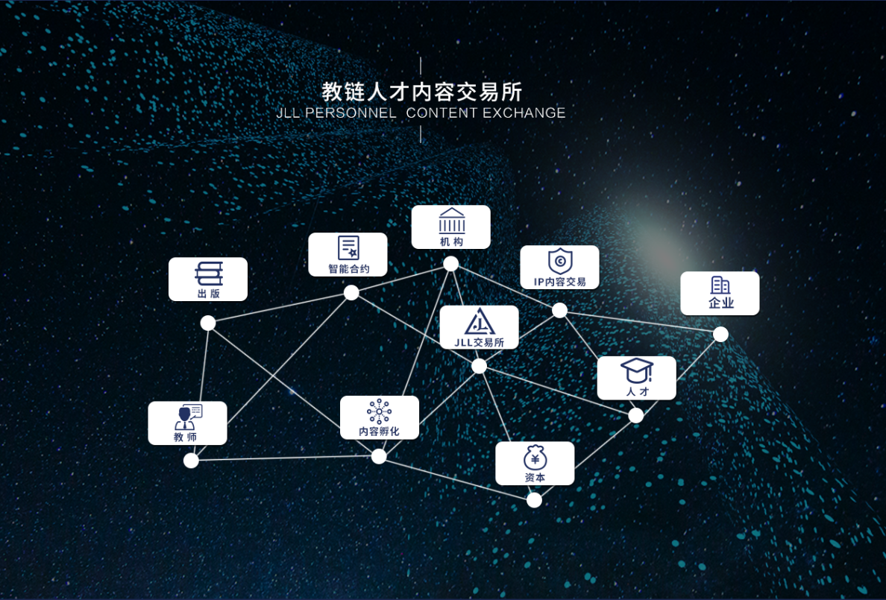

|  |  |
| --- | --- |
| 机构 | Organizations |
| IP内容交易 | IP content transaction |
| 企业 | Businesses |
| 人才 | Talents |
| 资本 | Capitals |
| 内容孵化 | Content hatching |
| JLL交易所 | JLL exchange |
| 智能合约 | Smart contract |
| 出版 | Publication |
| 教师 | Teachers |

基于JLL协议上的海量人才及其接受教育的认证数据、教师及其上传的教学内容。通过JLL生态，可以实现基于人才教育数据的人才与用人单位的交易，基于教师个人IP内容的认证、管理、孵化及与出版社、教育机构、资本等主体的版权交易等。当以上交易达到足够量时，教链人才及内容交易所也可得到推行。

A large number of talents and their education certification data, teachers and their uploaded teaching contents are based on JLL protocol. Based on education data, the JLL ecosystem achieves transaction between talents and employers. It also enables the certification, management, and hatch of IP contents based on individual teachers, and the copyright trades among presses, education organizations, and capitals. When the above trading volume is sufficient, the talent and content exchange can also be implemented.

1. 教链（JLL）智能合约协议

JLL smart contract protocol

教链公有链智能协议为共识，以“人才”、“教师”、“资本”、“用户”为分布，通过JLL协议，将IP内容、人才和资本转化为数字资产，同时进行新币孵化、投票。在用户获得收益的同时，最大化IP内容、人才和资本的价值，帮助其在教链的人才及内容交易所和生态内获得流动性。

The JLL public chain is based on the consensus of smart contract protocols and distributed over “talents”, ”teachers”, ”capitals” and “users”. The JLL protocol will convert the IP contents, talents and capitals into digital assets. It will also hatch new tokens and votes at the same time. While benefiting users, it will maximize the value of IP contents, talents and capitals and enable their liquidity in the talents and contents exchange and ecosystem.

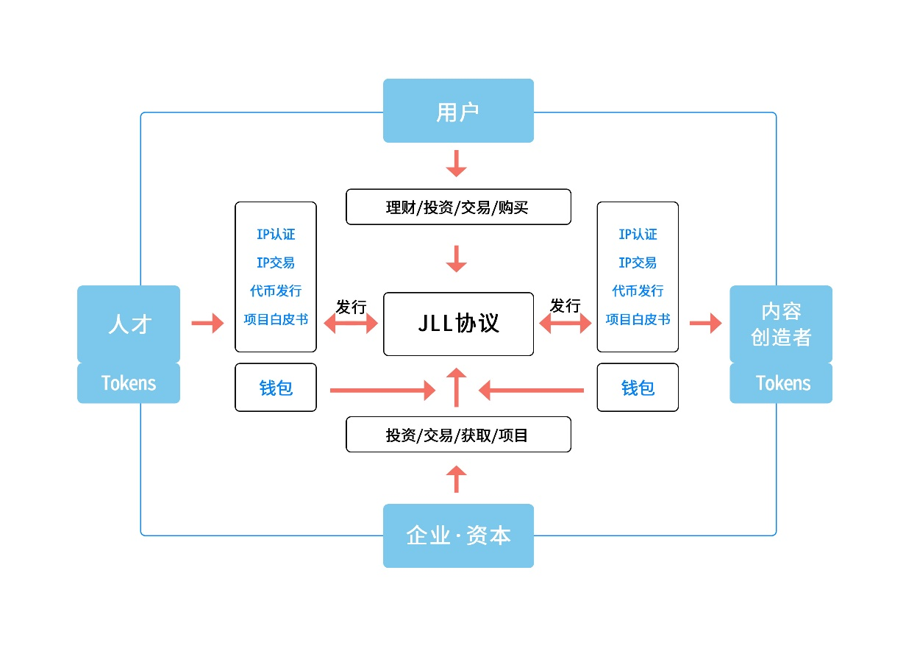

|  |  |
| --- | --- |
| 企业-资本 | Businesses-capitals |
| 用户 | Users |
| 内容创造者 | Content creators |
| 人才 | Talents |
| 发行 | Offering |
| JLL协议 | JLL protocol |
| 钱包 | Wallet |
| 理财、投资、交易、购买 | Finance management, investment, transaction, purchasing |
| 投资、交易、获取、项目 | investment, transaction, acquisition, project |

1. **教链（JLL）发行方案**

**JLL issue scheme**

JLL会基于以太坊ERC20标准发行Token - JLL，属性使用币。JLL作为一个教育垂直行业重要的经济工具，将在诸多场景被使用，例如：在线教育行业、人才招聘行业、内容出版行业，及人才、教育内容交易平台等。JLL 总量为 2000亿，其中1000亿锁仓用于POW，按下图方式进行分配：

JLL issues Token - JLL (a property utility token) based on the Ethereum ERC20 standard. As an important economic instrument in the vertical education industry, JLL will be applied in many scenarios, such as on-line education, talent recruitment, content publication, and exchanges for talents and teaching contents, etc. The total amount of JLL is 200 billion, of which 100 billion lockers are used for POW, as shown in the following figure:

|  |  |  |  |  |  |  |
| --- | --- | --- | --- | --- | --- | --- |
| JLL总量为2000亿 | | | | | | |
| 私募 | 团队 | 天使·基石 | 商务合作 | 社区 | 慈善基金 | 锁仓 |
| 10% | 12.5% | 7.5% | 5% | 5% | 10% | 50% |

|  |  |  |  |  |  |  |
| --- | --- | --- | --- | --- | --- | --- |
| The total JLL is 200 billion | | | | | | |
| Private placement | Team | Angel & Cornerstones | Business cooperation | Community | Charity fund | Locker |
| 10% | 12.5% | 7.5% | 5% | 5% | 10% | 50% |

10%，以私募形式发行。发行所获收入将用于支撑 JLL后续几年的运营，包括技术开发、市场拓展、法律咨询等；

12.5%，分配给创始团队和极早期贡献者。他们为 JLL 的早期发展提供资源和技术的支持；

7.5％，天使与基石用于为JLL特别贡献者；

5%，将用于商业合作推广。主要用于交易平台及媒体等合作；

5%，用于社区建设。主要包括品牌建设、社区生态构建、社区认知大学等；

10%，基金会持有的Token用于全球教育慈善基金， Token使用需要通过基金会管理委员会共同决策。

10% will be offered to private placement. The proceeds from the offering will be used to support JLL's operations in the next few years, including technology development, market development, legal advice, etc.

12.5% will be assigned to the founding team and extremely early contributors. They provided resources and technical supports for the early development of JLL;

7.5% Angels and cornerstones will be offered to JLL special contributors;

5% will be used for commercial cooperative promotion. Mainly used in cooperation with trading platforms and media;

5% for community building. It mainly includes brand building, community ecosystem construction, community cognition university, etc.

10% token held by the foundation is used for global education charity fund. Token use shall be jointly decided by the foundation management committee.

**七、教链（JLL）发展路径**

对于教链（JLL）来说，其整个体系的实现预计将会是一个为期 5 年、涉及5个步骤的庞大工程。具体来说，实现路径如下：

For JLL, the implementation of its entire system is expected to be a five-year, five-step project. Specifically, the implementation path is as follows:

1. 大梵天（计划）

Grand Brahma (Project)

重塑学习场景——Token激励社区各方共赢

Reshape the learning scene -- Token encourages all parties in the community to win

思维盘道阶段，建立JLL社区部落，实现POW挖矿应用，创立去中心化的思想殿堂，实现各方收益激励、学习分享，社区互动，价值排行，让平台与社区实现共治，让用户参与、学习、投票、分享、协作、为教育内容创造者提供一个去中心化生态。

Below activities are included in this stage: the establishment of JLL communities; the realization of POW mining applications; the creation of decentralized mind hall; the realization of income incentives; learning sharing; community interactions; value ranking; co-governance by the platform and the community; and the provision of a decentralized ecosystem through users’ engagement, learning, voting, sharing, and collaboration.

1. 因陀罗（计划）

Indra (Project)

重塑教育结构——基于DAPP去中心化，跨联盟Token支付

Reshape education structure -- based on DAPP decentralization and cross-alliance Token payment

JLL打造一个去中化的“人才”、“教师”、“机构”、“资本”共同构成教链人才内容交易所，各方成员可通过智能合约进行教育内容的IP认证、IP管理、IP孵化、IP交易，形成内容出版、交易，以及高端人才的流转。

JLL will build an exchange for talents and contents comprises of “talents”, “teachers”, “institutions” and “capitals”. All participants will be enabled to certify, manage, hatch, and trade IP education contents, thus facilitating the circulation of content publication, trade, and high-end talents.

1. [苏利](https://baike.baidu.com/item/%E8%8B%8F%E5%88%A9)耶（计划）

Surya (Project)

重塑教育交易——构建人才、教育交易生态

Reshape education trading -- build the trading ecosystem of talents and education

JLL打造一个去中化的“人才”、“教师”、“机构”、“资本”共同构成教链人才内容交易所，各方成员可通过智能合约进行教育内容的IP认证、IP管理、IP孵化、IP交易，形成内容出版、交易，以及高端人才的流转。

JLL will build an exchange for talents and contents comprises of “talents”, “teachers”, “institutions” and “capitals”. All participants will be enabled to certify, manage, hatch, and trade IP education contents, thus facilitating the circulation of content publication, trade, and high-end talents.

1. 伐楼那（计划）：

Varuna (Project)

触摸未来教育——人才IPO数字资产化，教育内容创造者数字资产化

Touch education in the future -- talent IPOs and education content creators will be converted into digital assets.

通过数字资产助其快速实现人才及内容创作者自我价值，扩大交投规模，实现价值创造，包括对项目的筛选、评估、风险把控、领投、私募融资、发币、上线交易及后期服务等，实现教育产业全过程的孵化，让更多的教育创新项目插上区块链技术的翅膀；通过分布式、去中心化的账户管理及数字资产化的价值体现模式，让教育创新项目突破目前面临的痛点、优化其教育创新项目产业结构。

The self-value of talents and content creators are quickly realized through digital assets. Value creation activities are enabled through trade and investment volume. Such activities include the selection, evaluation and risk management of projects; leading investment; private financing; token issuing; on-line trading and after-market service, etc. During this process, more and more education innovation projects are empowered by block chain technology; by adopting a value model based on distributed and decentralized ledger management and digital assets, these education innovation projects will address the current sore points and optimize their industrial structures.

1. 迦楼罗（计划）：

Calura (Project)

教育区块链生态组织者——教育内容区块链平台系统运作模式

The organizer of education block chain ecosystem-- the operation mode of education content block chain platform system

JLL教链的机制的核心要素是选举，每个系统原生代币的持有者（教育内容区块链平台代币 JLL的持有者）都可以参与选举，所持有的JLL余额即为投票权重。通过投票选举出理事会成员，也可以就平台发展方向的议题表明态度，这一切构成了JLL社区自治的基础。理事会人选由社区选举产生，理事会是JLL Chain的权力机构，理事会成员有权发起议案和对议案进行投票表决。未来通过去中化的社区管理机制，才能真正实现一个世界级去中化分布式教育生态诞生。

Election is the core element of JLL mechanism. The holders of primitive tokens in each system (e.g., the holders of JLL token in the education content block chain platform) are entitled to join the election, with their JLL balance being voting weights. They will either elect council members by voting, or state their attitudes towards the topics concerning the development direction of the platform. All these have constituted the foundation of JLL community autonomy. The council is elected by the community and is the power organ of the JLL Chain. The council members have the rights to initiate and vote for bills. In the future, a world-class decentralized and distributed education ecosystem can be truly realized through the decentralized community management mechanism.

**八．教链（JLL）核心成员、顾问及投资机构**

**JLL’s core members, consultants and investment institutions**

1. 营运团队

Operation team



Jason Wood

Chairman of JLLchain Education Foundation



Tang Jingjie

Sponsor of JLL China

Blockchain Application Architect

Blockchain Angel Investor



Kong Ling

Co-founder of JLL

Chinese Community Promoters

Chairman of Zhongju Blockchain



Lei Zi

Co-founder of JLL

Blockchain Technologist

Digital Currency Wallet Technologist



Tian Xu

JLL Project Operation Officer

Early investors in digital assets

Digital Asset Quantifier



Yan Yuhan

Community Operation Officer

Community Practitioners

Jingdong Internet Community Operation Expert



Xu Zhiqing

Community Operation Supervisor

Tencent Community Management Expert



ChenKai

Content Operation Officer

New media operation

Former content writer of an Alibaba company



Zhang Zhen

Chief Product Design Officer

Brand Designer

UI Front-end Designer



Wu Yurong

Full Stack Development Engineer  
Blockchain Technology Enthusiast   
Digital Currency Early Holder

1. 顾问团队

Consultant team



Zhang Yi

Digital Currency Angel Investor

Co-founder of Biqu

Consultants for many exchanges



Liang Kaien

Asia's top orator

Board Chairman of Beyong the Limit



Zhu Shao-ping

Former Director of the Financial and Economic Commission of the NPC

The Author of several policy and legal documents



Wu Zhengkuan

China marketing guru

Superspeaker



Shi YanIMG_256

China's top 10 planning lecturers

Brand China Deputy Secretary General

Founder of Dream Works Project



Ji JianJing

Speaker, Writer, Philanthropist, Entrepreneur

Chairman of Xuanyuan International Industrial Group

1. **投资机构**

**Investment institutions**

**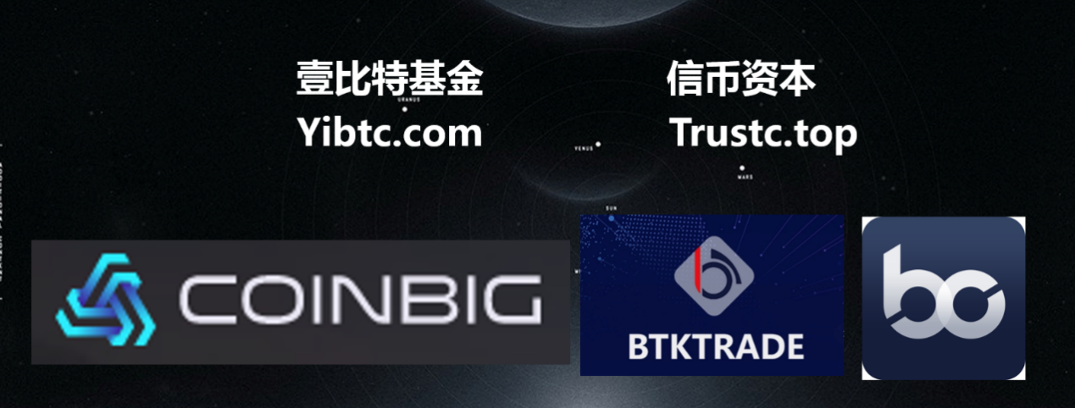**

1. **预计时间表**

**Estimated schedule**

**大梵天**

重塑学习场景——Token激励社区各方共赢

2018年4月-2018年10月完成

**Grand brahma**

Reshape the learning scene -- Token encourages all parties in the community to win

From April 2018 to October 2018

**因陀罗**

重塑教育结构——基于DAPP去中心化，跨联盟Token支付

2018年10月-2019年10月完成

**Indra**

Reshape education structure -- based on DAPP decentralization and cross-alliance Token payment

From October 2018 to October 2019

**苏利耶**

重塑教育交易——构建人才、教育交易生态

2019年10月-2020年9月完成

**Surya**

Reshape education trading -- build the trading ecosystem of talents and education

From October 2019 to September 2020

**伐楼那**

触摸未来教育——人才IPO数字资产化，教育内容创造者数字资产化

2020年9月-2021年10月完成

**Varuna**

Touch education in the future -- talent IPOs and education content creators will be converted into digital assets.

From September 2020 to October 2021

**迦楼罗**

教育区块链生态圈——教育内容区块链平台系统运作模式

2021年11月-2022年12月完成

**Karura**

Education block chain ecosystem -- the operation mode of education content block chain platform system

From November 2021 to December 2022

1. **项目风险**

**Project risks**

1. 政策风险

Policy risks

区块链目前尚处于早期，国家对于区块链项目的监管政策上不明确，这有可能对项目的发展和流动性产生不确定影响。目前数字资产价值波动巨大，存在暴涨暴跌、庄家操控的风险。投资风险相对较大，参与者可能缺乏市场经验，无法把握市场的不确定性。这有可能会带来资产的冲击和心理压力，投资者需要有较强的承受能力，请各位参与者谨慎参与。

At present, the blockchain is still at an early stage and the national regulatory policy on blockchain projects is not clear, which may have uncertain impacts on the development and liquidity these projects. At present, the value of digital assets fluctuates dramatically, and there is a risk of inflation and collapse and manipulation by the makers. Investment risk is relatively huge. Participants may lack market experience and are unable to grasp market uncertainty. This may impact the assets and generate psychological pressure. Investors need to have a strong resilience. Therefore, investors are advised to be cautious before participating in the investment.

1. 团队风险

Team risk

JLL教链目前拥有一支在线教育和区块链领域从业经验资深的小伙伴组成。团队内部当前稳定，凝聚力强，在今后的发展过程中，不排除有核心人员离开，团队内部发生冲突而导致JLL受到负面影响的可能性。

JLL currently has a team comprises of experts experienced in on-line education and block chain. The team is stable and cohesive at present. In the future development process, core personnel might leave and there might be conflicts within the team. This will pose negative influence on JLL.

1. 竞争风险

当前区块链行业项目众多，竞争十分激烈，JLL教链借助其目前的核心团队成员快速成长，运营推广。强大的市场竞争，会给项目带来压力，项目是否能在诸多优秀项目中得到广大市场认可，这和团队本身有关，也收到市场上诸多竞争对手的影响，不排除会面临恶性竞争的可能。

At present, there are many projects in the blockchain industry, and the competition is very fierce. JLL is now developing rapidly with the efforts of its core team members. Fierce market competition will bring pressure to the project. Whether the project could be the winner among all these outstanding competitors on the market is not only subject to the team’s work, but also impacted by its competitors. In other words, the project might be faced with vicious competitions.

1. 黑客风险

Hacker risks

在安全性方面，我们一直以最高标准要求自己，也收到过来自黑客的威胁，我们都已应对。但黑客的攻击依然无法避免，随着JLL教链数字资产的增值，更容易成为犯罪分子的攻击目标，存在一些不可预知的风险。

In terms of security, we have been demanding ourselves to the highest standards. We have addressed all the previous threats from hackers. However, hacker attacks are still inevitable. As the value of JLL’s digital assets increases, it is more likely to become the target of criminals. Besides, there are some unpredictable risks.

**免责声明**

**Disclaimer**

本白皮书，仅作为产品介绍，传达信息之用，不作为投资参考。本文档不构成也不理解为提供任何互换行为指导，所有互换都是自愿原则。相关意向用户请明确了解JLL教链的风险，投资者一旦参与投资即表示接受了该项目风险，并愿意维持承担一切相应后果。

本公司不承担任何参与JLL项目造成的直接或间接资产损失。

This white paper is only used for product introduction and information transmission. One shall not regard it as investment reference. This document does not constitute, nor is it construed to provide, any guidance on the conduct of swaps, all of which are voluntary. Interested users should clearly understand the risks of JLL. Once investors participate in the investment, they will accept the risks of the project and are willing to bear all the corresponding consequences.

The company shall not be liable for any direct or indirect asset losses caused by any participation in JLL project.

**结语**

**Conclusion**

以教为生·以链为终

Teaching · Chain

JLL以敬畏之心面对全球教育产业结构，渴望借助区块链技术，让教育插上区块链的翅膀腾飞，同时也期望通过 JLL教育协议，特别是教育垂直的各方人士及其背后的价值更好的流通交融。作为一个热爱技术变革的团队，我们也期望透过 JLL，尤其是 JLL教育 协议，为区块链技术的积累和进步，贡献力量。

JLL desires to empower the development of education industry by using block chain technology. Meanwhile, it expects to facilitate better circulation and integration among all participants in the vertical education industry and their underlying value through the implementation of JLL education protocol. As a team who embrace technological changes, we also expect to contribute to the accumulation and progress of blockchain technology through JLL, especially JLL education protocol.